Spring festival traditions and customs PPT vocabulary
春节传统和习俗词汇
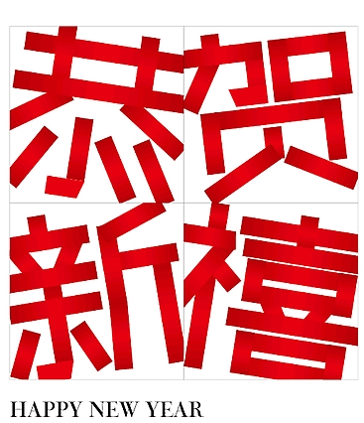
- 春节chūn jié___________________________________________
- 过年ɡuò nián__________________________________________
- 祭灶神jì zào shén______________________________________
- 扫房子sǎo fánɡ zi /大扫除dà sǎo chú______________________
- 做豆腐zuò dòu fu______________________________________
- 蒸馒头zhēnɡ mán tou___________________________________
- 买年货mǎi nián huò /办年货bàn nián huò
_____________________________________________________
- 买新衣mǎi xīn yī ______________________________________
- 装饰房子 zhuānɡ shì fánɡ zǐ _____________________________
10.贴福字tiē fú zì ______________________________________
11.贴窗花tiē chuānɡ huā__________________________________
12.贴年画tiē nián huà ____________________________________
13.贴春联tiē chūn lián /贴对联tiē duì lián
_____________________________________________________
14.贴门神tiē mén shén____________________________________
15.做年糕zuò nián ɡāo____________________________________
16.包饺子bāo jiǎo zi ____________________________________
17.吃年饭chī nián fàn ____________________________________
18.发红包fā hónɡ bāo /给红包ɡěi hónɡ bāo
_____________________________________________________
19.拜年bài nián__________________________________________
20.舞狮wǔ shī __________________________________________
21.舞龙 wǔ lónɡ__________________________________________
22.过元宵节ɡuò yuán xiāo jié /闹元宵nào yuán xiāo
_____________________________________________________
23.吃汤圆 chī tānɡ yuán /吃元宵chī yuán xiāo_________________
24.猜灯谜 cāi dēnɡ mí ____________________________________
25.放鞭炮fànɡ biān pào /放炮竹fànɡ pào zhú________________
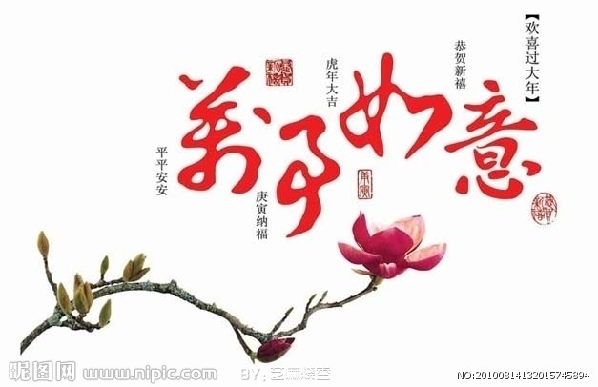
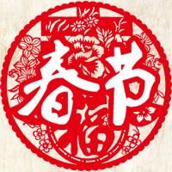  1.春节chūn jié | 2.过年ɡuò nián
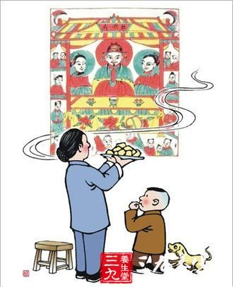  3.祭灶神jì zào shén | 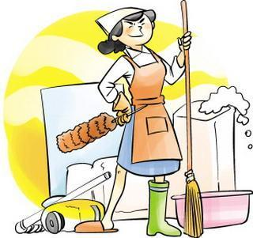  4.扫房子sǎo fánɡ zi /大扫除dà sǎo chú
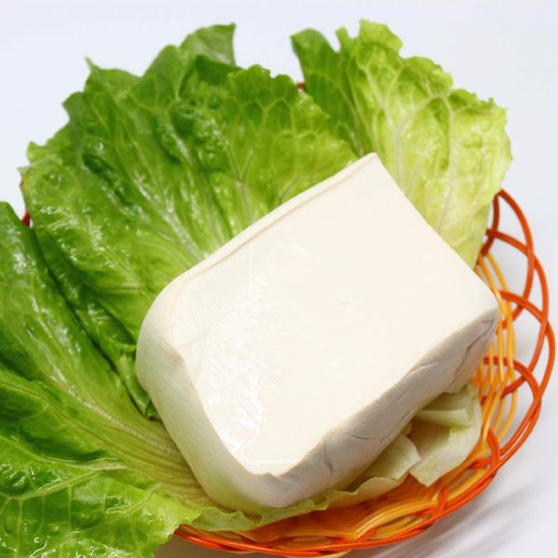  5.做豆腐zuò dòu fu | 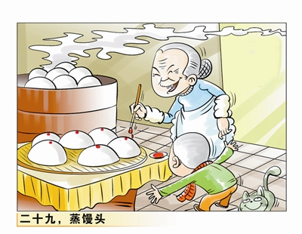  6.蒸馒头zhēnɡ mán tou
7.买年货mǎi nián huò/办年货bàn nián huò | 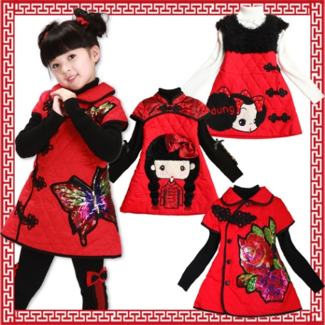  8.买新衣mǎi xīn yī
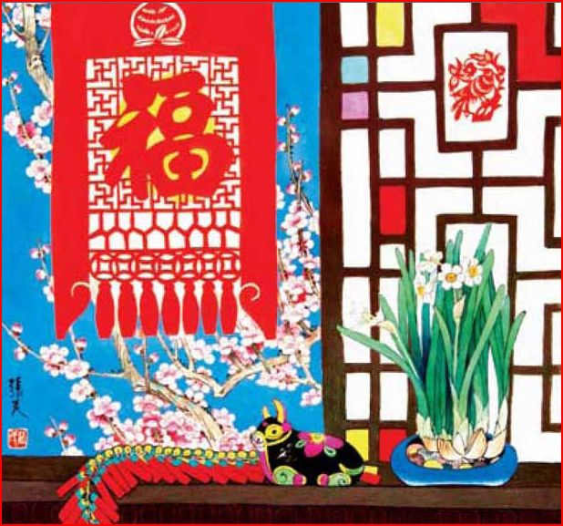  9.装饰房子 zhuānɡ shì fánɡ zǐ | 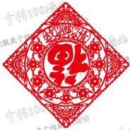  10.贴福字tiē fú zì
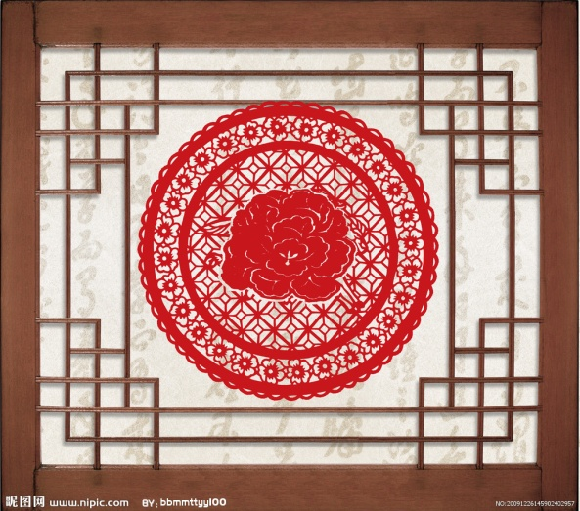  11.贴窗花tiē chuānɡ huā | 12.贴年画tiē nián huà
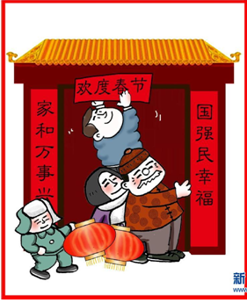  13.贴春联tiē chūn lián /贴对联tiē duì lián | 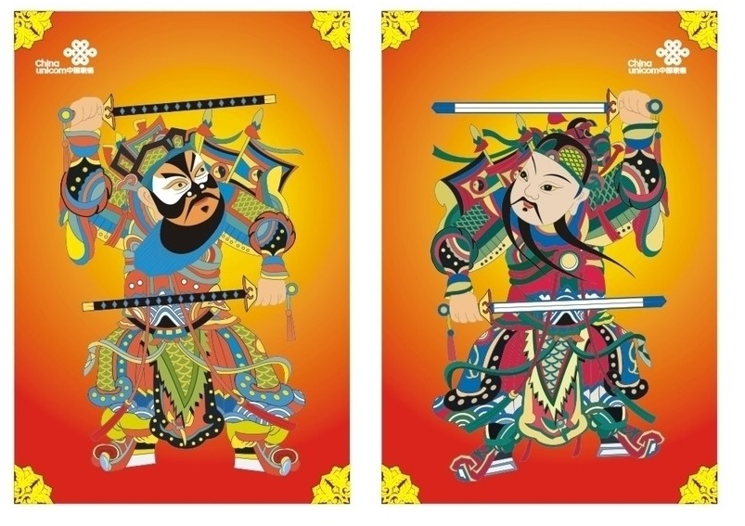  14.贴门神tiē mén shén
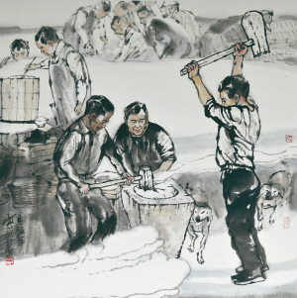  15.做年糕zuò nián ɡāo | 16.包饺子bāo jiǎo zi
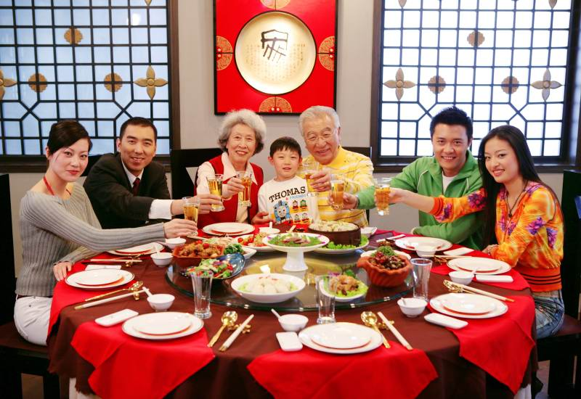  17.吃年饭chī nián fàn | 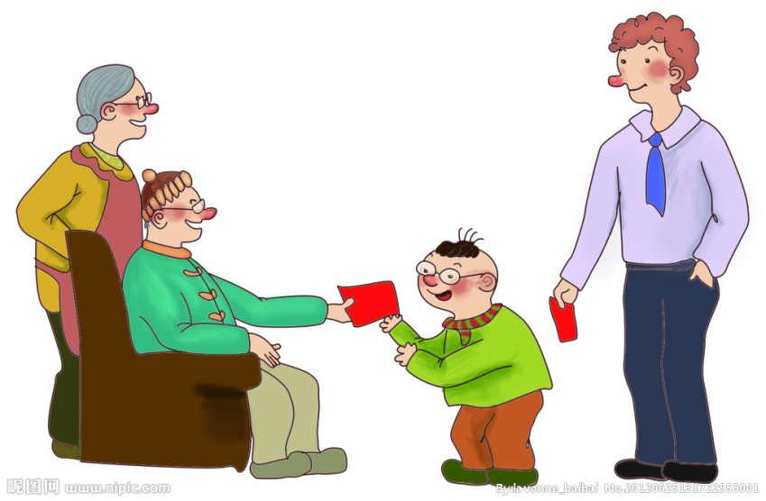  18.发红包fā hónɡ bāo/给红包ɡěi hónɡ bāo
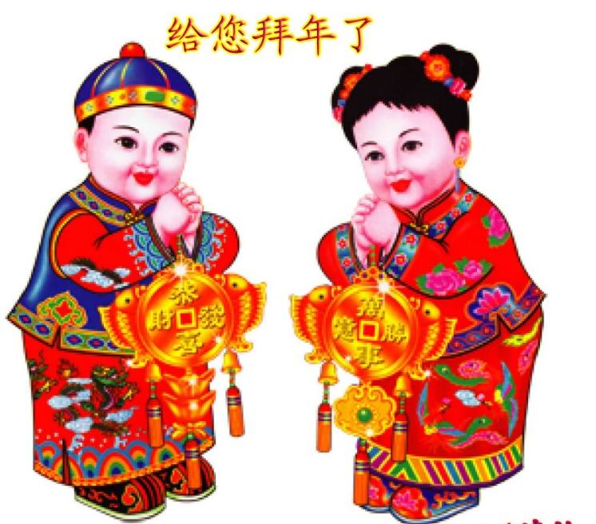  19.拜年bài nián | 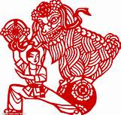  20.舞狮wǔ shī
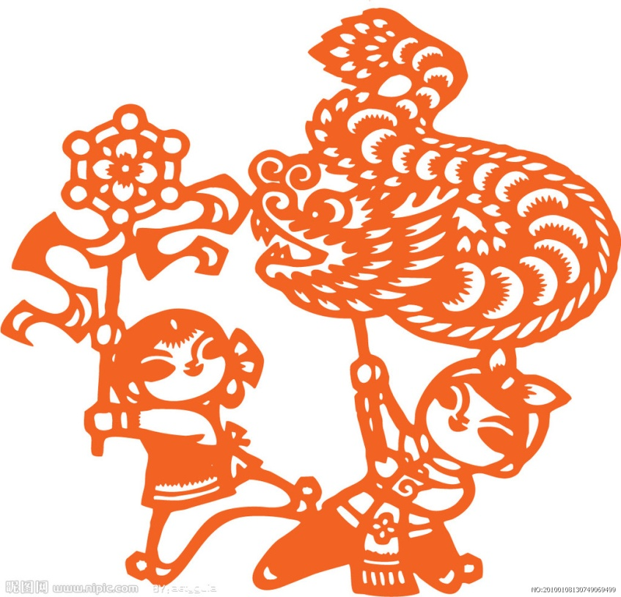  21.舞龙 wǔ lónɡ | 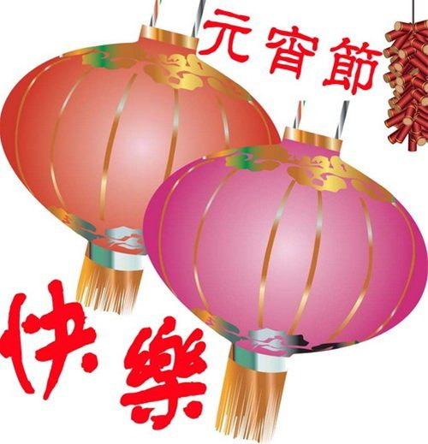  22.过元宵节ɡuò yuán xiāo jié  /闹元宵nào yuán xiāo
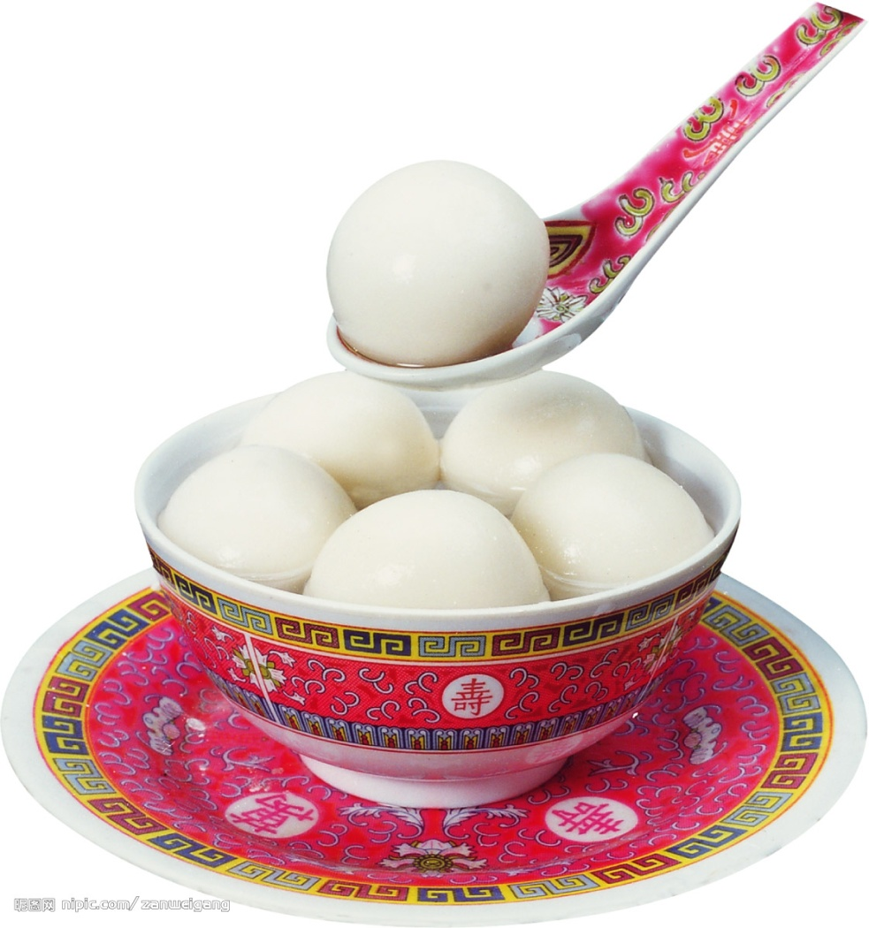  23.吃汤圆 chī tānɡ yuán  /吃元宵chī yuán xiāo | 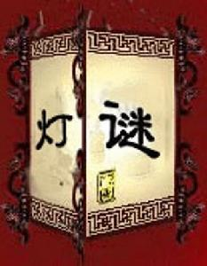  24.猜灯谜 cāi dēnɡ mí
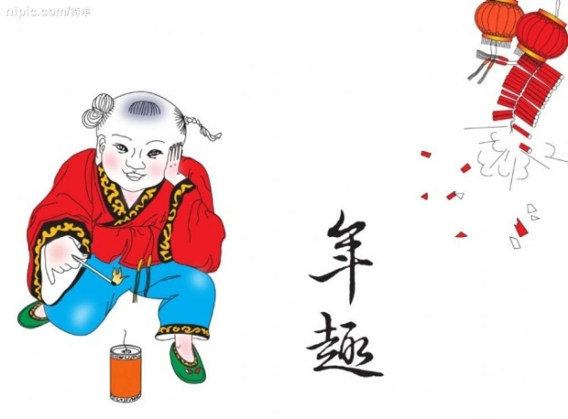  25.放鞭炮fànɡ biān pào /放炮竹fànɡ pào zhú | 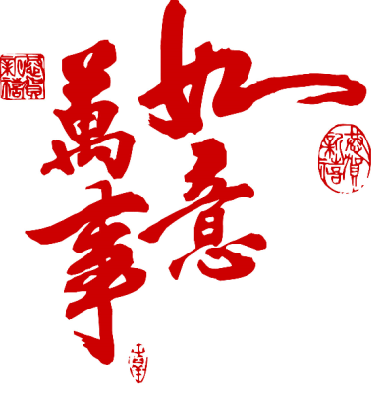  26.
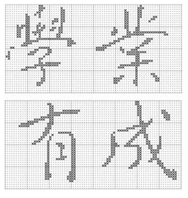  27. | 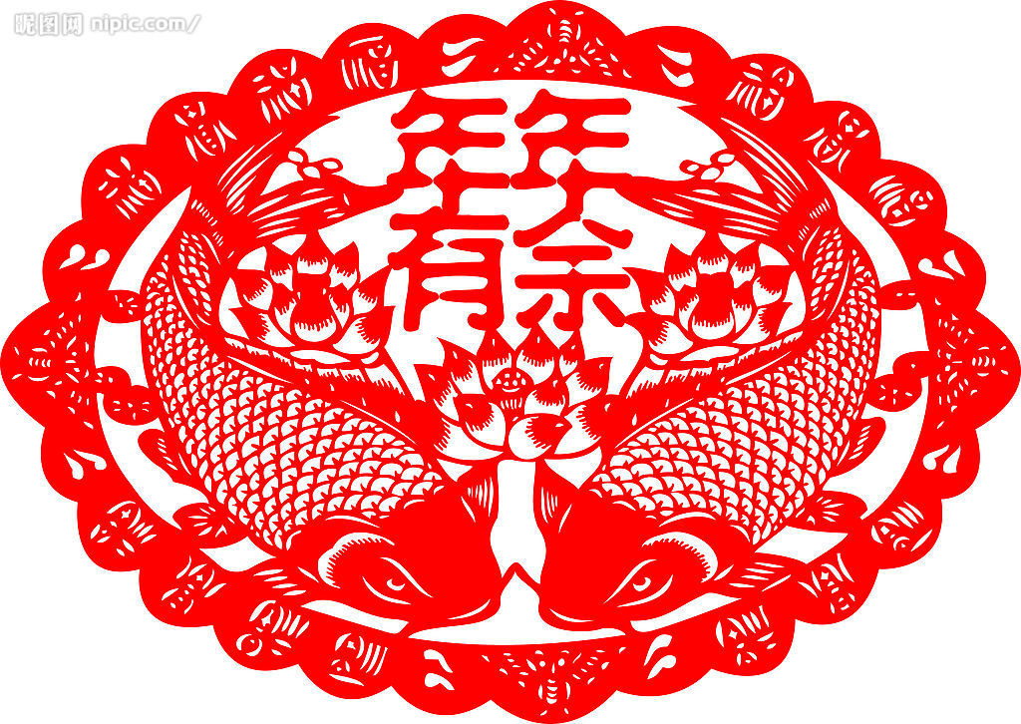  28.

