Sports PPT Vocabulary

1.体育tǐ yù _________________________________________________________
2.东道国dōnɡ dào ɡuó_________________________________________________
3.参赛国cān sài ɡuó _________________________________________________
4.裁判cái pàn ________________________________________________________
5.教练jiào liàn ______________________________________________________
6.运动员yùn dònɡ yuán_________________________________________________
7.体育馆tǐ yù ɡuǎn _________________________________________________
8.运动场yùn dònɡ chǎnɡ _______________________________________________
9.比赛bǐ sài ________________________________________________________
10.开幕式kāi mù shì___________________________________________________
11.田径tián jìnɡ ___________________________________________________
12.游泳yóu yǒnɡ ______________________________________________________
13.跳水tiào shuǐ _____________________________________________________
14.高尔夫球ɡāo ěr fū qiú ______________________________________________
15.橄榄球ɡǎn lǎn qiú___________________________________________________
16.曲棍球qū ɡùn qiú ___________________________________________________
17.羽毛球yǔ máo qiú ___________________________________________________
18.乒乓球pīnɡ pānɡ qiú ________________________________________________
19.足球zú qiú _________________________________________________________
20.篮球lán qiú ________________________________________________________
21.排球pái qiú ________________________________________________________
22.网球wǎnɡ qiú _______________________________________________________
23.棒球bànɡ qiú _______________________________________________________
24.垒球lěi qiú _______________________________________________________
25.手球shǒu qiú _______________________________________________________
26.体操tǐ cāo _______________________________________________________
27.赛艇sài tǐnɡ _______________________________________________________
28.帆船fān chuán _______________________________________________________
29.射击shè jī __________________________________________________________
30.射箭shè jiàn_________________________________________________________
31.击剑jī jiàn ________________________________________________________
32.拳击quán jī _________________________________________________________
33.摔跤shuāi jiāo ______________________________________________________
34.柔道róu dào _______________________________________________________
35.举重jǔ zhònɡ _______________________________________________________
36.跆拳道tái quán dào___________________________________________________
37.马术mǎ shù _________________________________________________________
38.自行车zì xínɡ chē ___________________________________________________
39.蹦床bènɡ chuánɡ ____________________________________________________
40.滑雪huá xuě _________________________________________________________
41.滑冰huá bīnɡ ________________________________________________________
42.团体项目tuán tǐ xiànɡ mù ____________________________________________
43. 个人项目ɡè rén xiànɡ mù _____________________________________________
44. 淘汰赛táo tài sài ___________________________________________________
45.半决赛bàn jué sài ____________________________________________________
46.决赛jué sài __________________________________________________________
47.输shū ________________________________________________________________
48.赢yínɡ_______________________________________________________________
49.平局pínɡ jú__________________________________________________________
50.犯规fàn ɡuī__________________________________________________________
51.纪录保持者jì lù bǎo chí zhě___________________________________________
52.全能冠军quán nénɡ ɡuàn jūn ___________________________________________
53.冠军ɡuàn jūn/第一名dì yì mínɡ_________________________________________
54.亚军yà jūn/第二名dì èr mínɡ __________________________________________
55.季军jì jūn /第三名dì sān mínɡ ________________________________________
56.金牌jīn pái __________________________________________________________
57.银牌yín pái __________________________________________________________
58.铜牌tónɡ pái _________________________________________________________
59.颁奖典bān jiǎnɡ diǎn lǐ/发奖仪式fā jiǎnɡ yí shì ______________________
60.闭幕式bì mù shì_______________________________________________________

  1.体育tǐ yù | 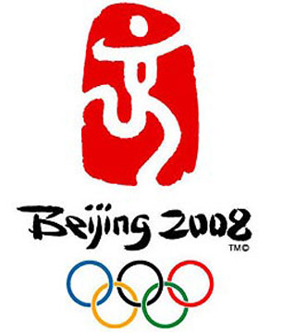  2.东道国dōnɡ dào ɡuó
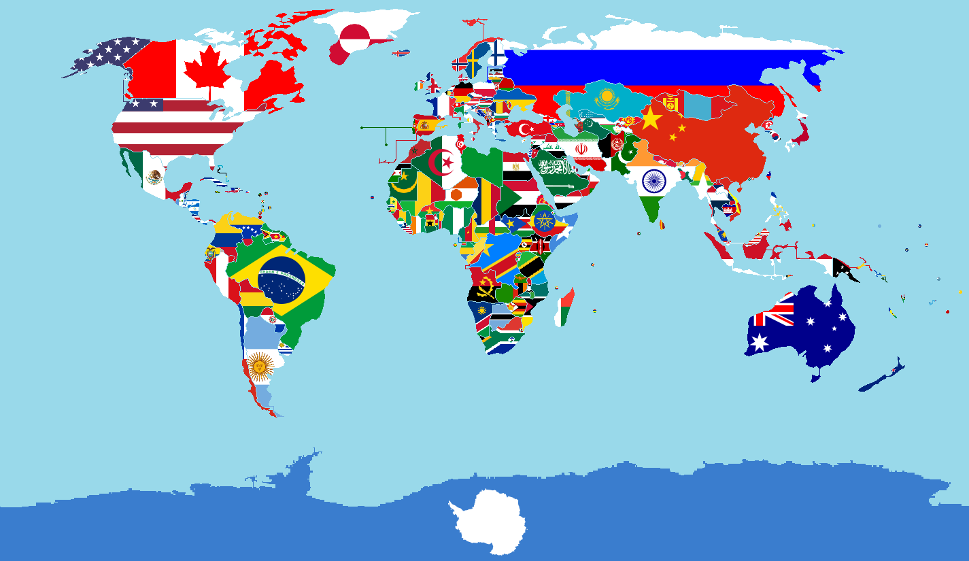  3.参赛国cān sài ɡuó | 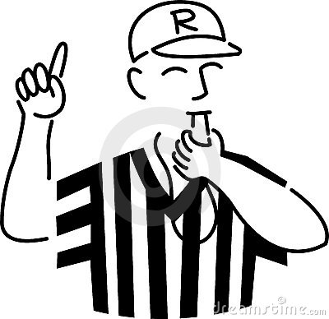  4.裁判cái pàn
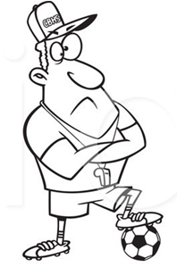  5.教练jiào liàn |   6.运动员yùn dònɡ yuán
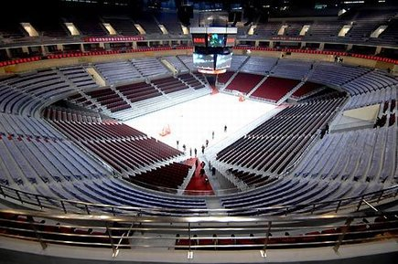  7.体育馆tǐ yù ɡuǎn | 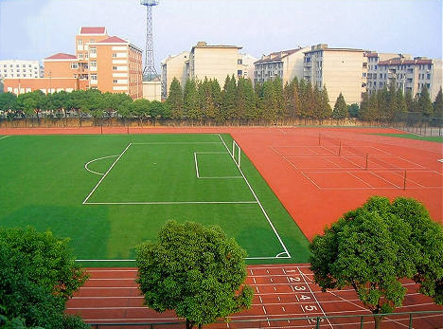  8.运动场yùn dònɡ chǎnɡ
  9.比赛bǐ sài | 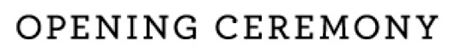  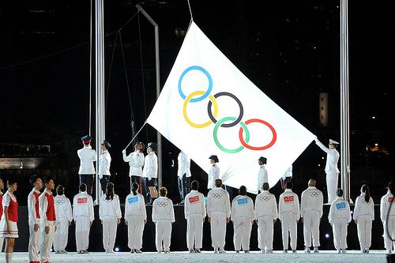  10.开幕式kāi mù shì
  11.田径tián jìnɡ |   12.游泳yóu yǒnɡ
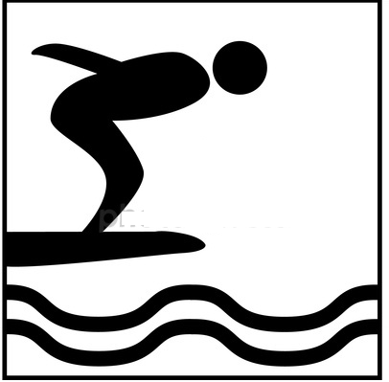  13.跳水tiào shuǐ | 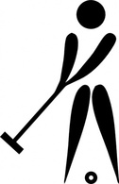  14.高尔夫球ɡāo ěr fū qiú
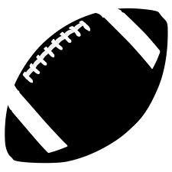  15.橄榄球ɡǎn lǎn qiú | 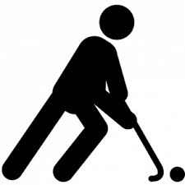  16.曲棍球qū ɡùn qiú
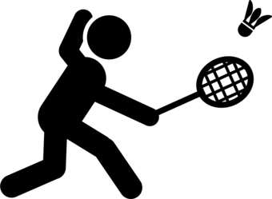  17.羽毛球yǔ máo qiú | 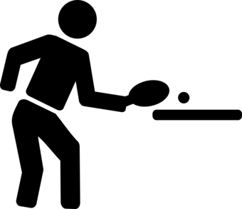  18.乒乓球pīnɡ pānɡ qiú
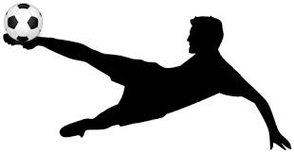  19.足球zú qiú | 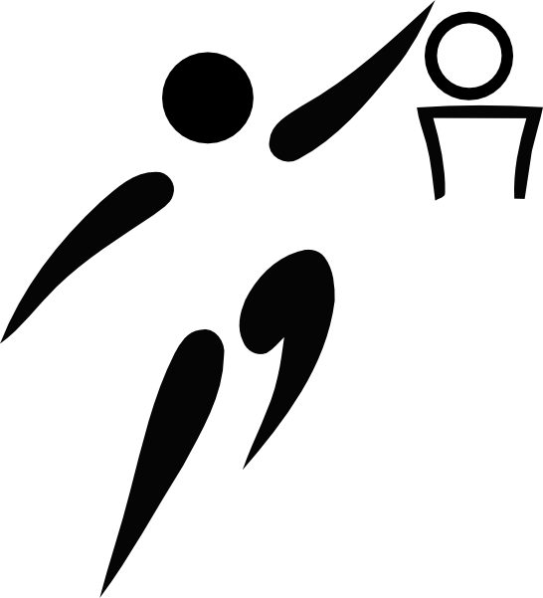  20.篮球lán qiú
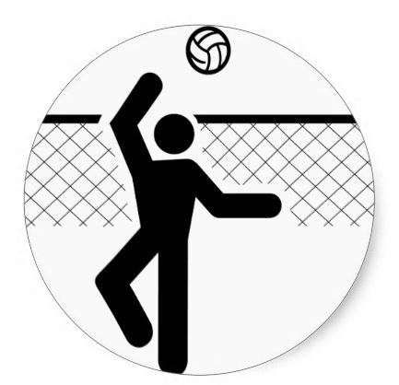  21.排球pái qiú | 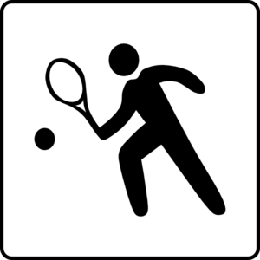  22.网球wǎnɡ qiú
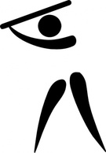  23.棒球bànɡ qiú | 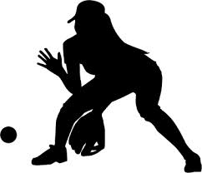  24.垒球lěi qiú
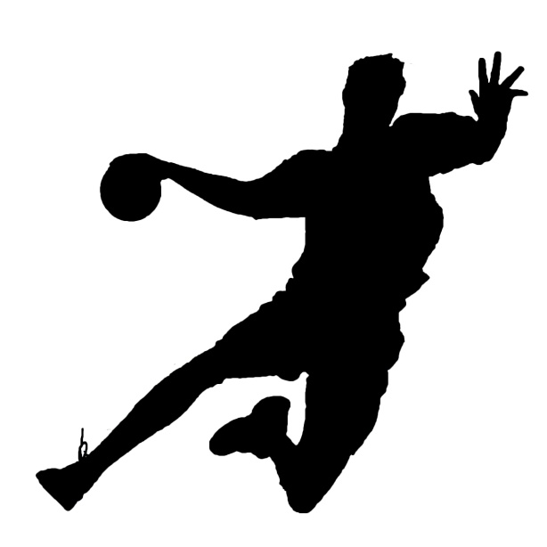  25.手球shǒu qiú | 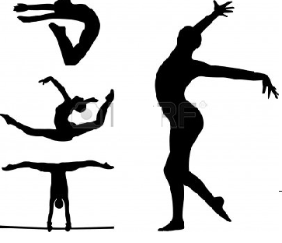  26.体操tǐ cāo
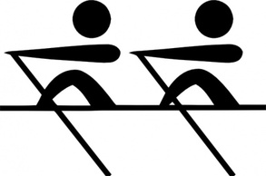  27.赛艇sài tǐnɡ | 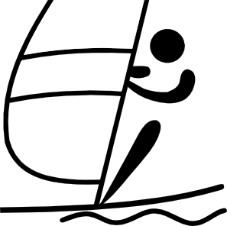  28.帆船fān chuán
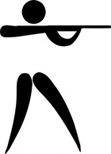  29.射击shè jī | 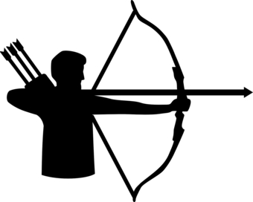  30.射箭shè jiàn
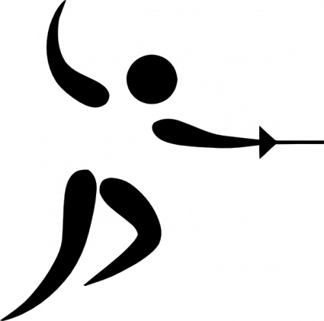  31.击剑jī jiàn | 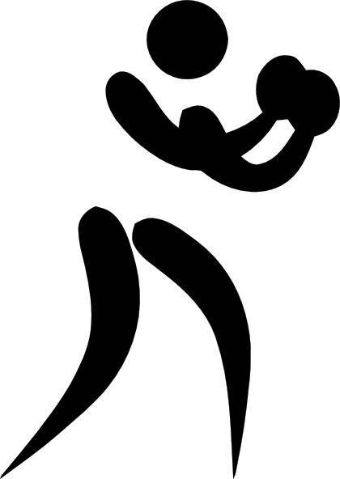  32.拳击quán jī
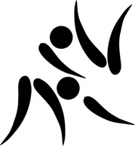  33.摔跤shuāi jiāo | 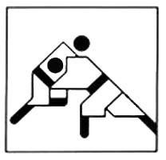  34.柔道róu dào
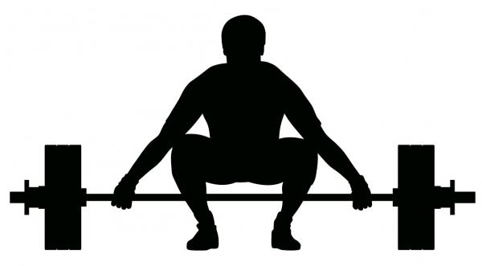  35.举重jǔ zhònɡ |   36.跆拳道tái quán dào
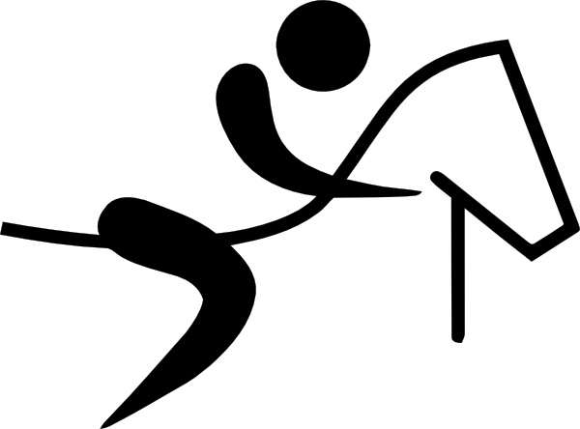  37.马术mǎ shù | 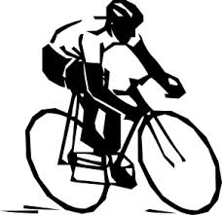  38.自行车zì xínɡ chē
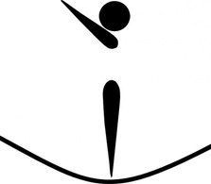  39.蹦床bènɡ chuánɡ | 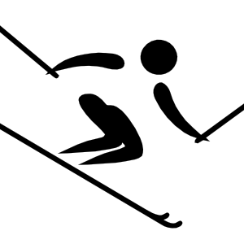  40.滑雪huá xuě
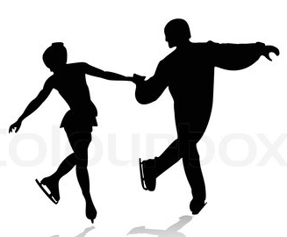  41.滑冰huá bīnɡ |   42.团体项目tuán tǐ xiànɡ mù
  43. 个人项目ɡè rén xiànɡ mù | 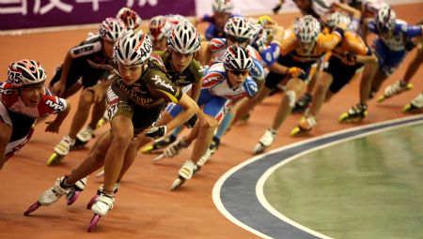  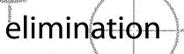  44.淘汰赛táo tài sài
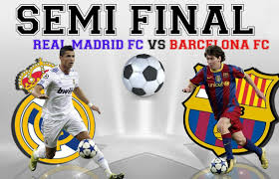  45.半决赛bàn jué sài | 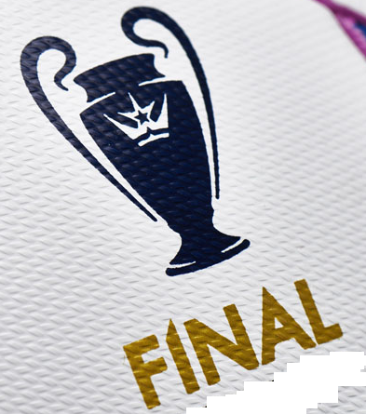  46.决赛jué sài
  47.输shū |   48.赢yínɡ
  49.平局pínɡ jú | 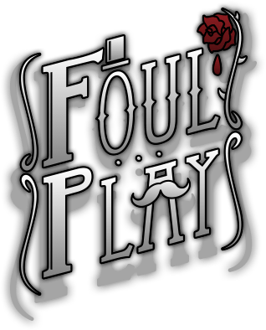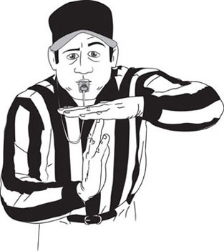  50.犯规fàn ɡuī
  51.纪录保持者jì lù bǎo chí zhě |   52.全能冠军quán nénɡ ɡuàn jūn
  53.冠军ɡuàn jūn/第一名dì yì mínɡ | 54.亚军yà jūn/第二名dì èr mínɡ
55.季军jì jūn /第三名dì sān mínɡ | 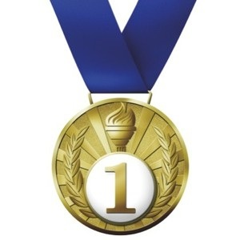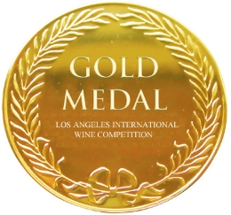  56.金牌jīn pái
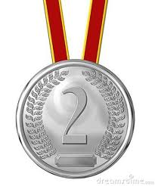  57.银牌yín pái | 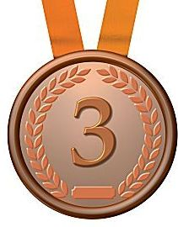  58.铜牌tónɡ pái
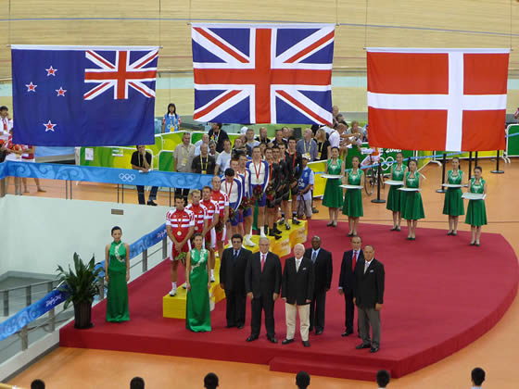  59. 颁奖典bān jiǎnɡ diǎn lǐ  /发奖仪式fā jiǎnɡ yí shì | 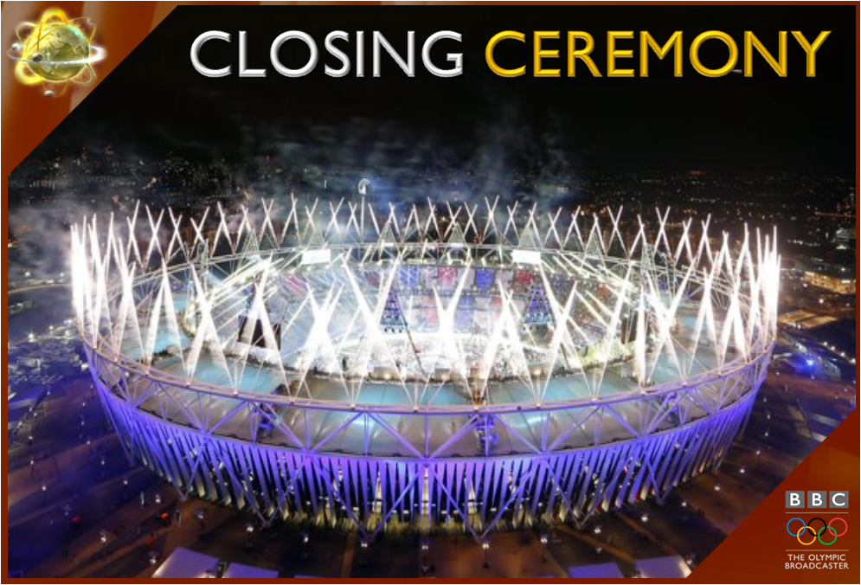  60.闭幕式bì mù shì

