PPT Vocabulary文具(wén jù)PPT词汇:
1. 橡皮擦xiànɡ pí cā _________________________________
2. 剪刀jiǎn dāo _______________________________________
3.蜡笔là bǐ ___________________________________________
4.铅笔qiān bǐ_________________________________________
5.水彩笔shuí cǎi bǐ____________________________________
6.书包shū bāo _________________________________________
7.文件夹wén jiàn jiá __________________________________
8.订书机dìnɡ shū jī __________________________________
9.胶水jiāo shuǐ_______________________________________
10.透明胶tòu mínɡ jiāo _______________________________
11.打孔机dǎ kǒnɡ jī___________________________________
12.计算机jì suàn jī___________________________________
13.笔记本bǐ jì běn___________________________________
14.尺子chǐ zi_________________________________________
15.卷笔刀juǎn bǐ dāo___________________________________
16.回形针huí xínɡ zhēn_________________________________
17.桌子zhuō zi_________________________________________
18.椅子yǐ zi _________________________________________
19.桌子、椅子摆整齐。zhuō zi 、 yǐ zi bǎi zhěnɡ qí
______________________________________________________
20.不要随地扔垃圾！bú yào suí dì rēnɡ lā jī
______________________________________________________

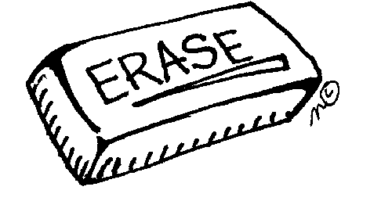  1．橡皮擦 xiànɡ pí cā | 2．剪刀jiǎn dāo
3. 蜡笔là bǐ | 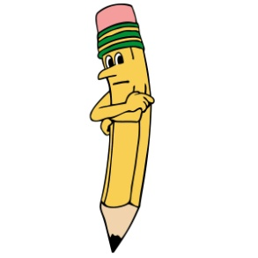  4. 铅笔qiān bǐ
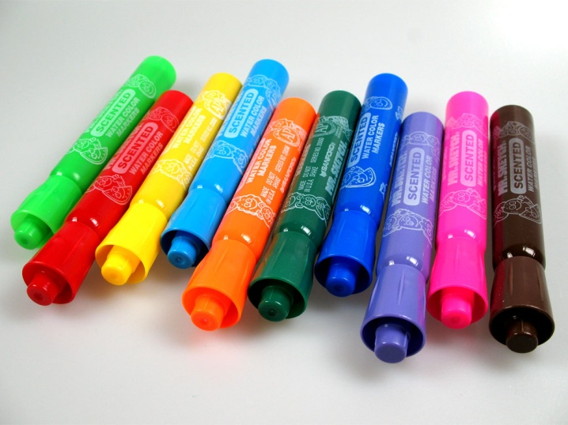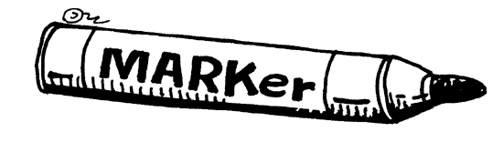  5.水彩笔shuí cǎi bǐ | 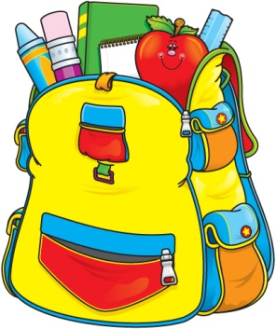  6. 书包shū bāo
7. 文件夹wén jiàn jiá | 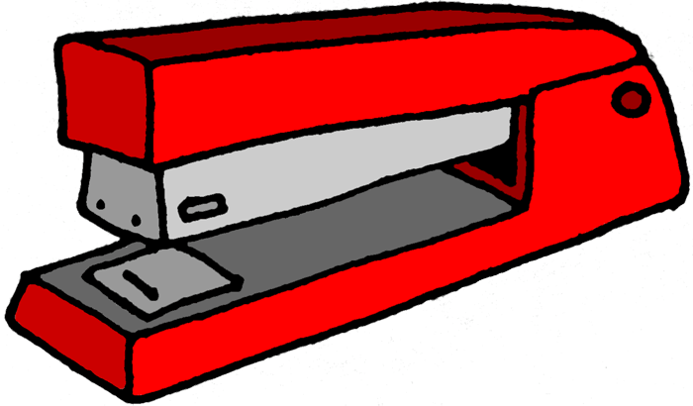  8. 订书机dìnɡ shū jī
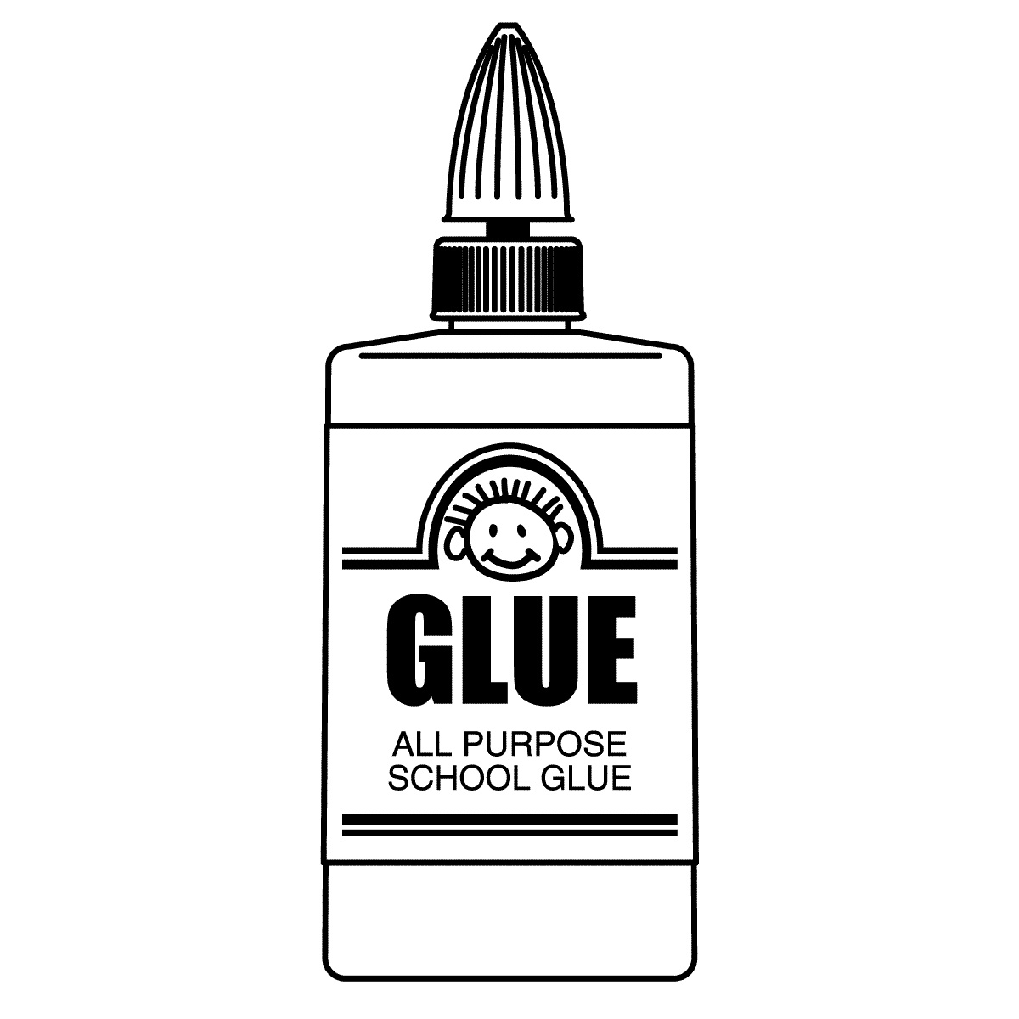  9.胶水jiāo shuǐ | 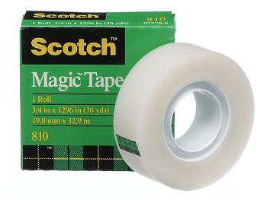  10. 透明胶tòu mínɡ jiāo
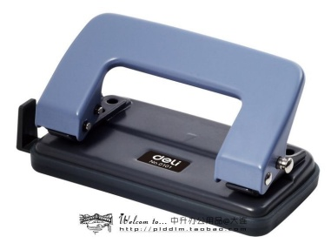  11. 打孔机dǎ kǒnɡ jī | 12.计算机jì suàn jī
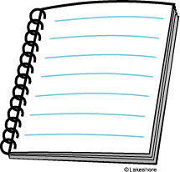  13.笔记本bǐ jì běn | 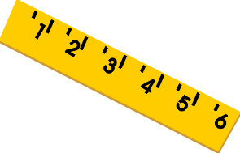  14.尺子chǐ zi
15卷笔刀 juǎn bǐ dāo | 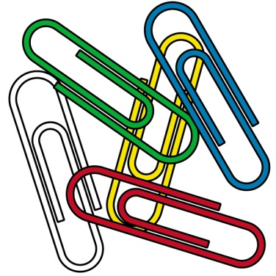  16.回形针huí xínɡ zhēn
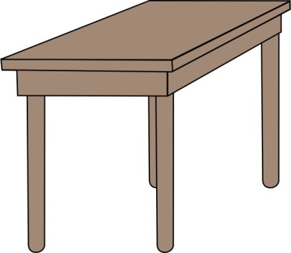  17. 桌子zhuō zi | 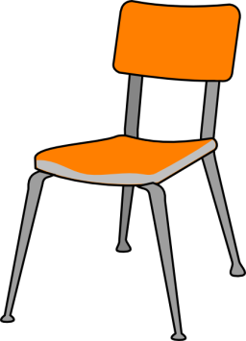  18椅子yǐ zi
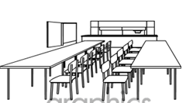  19.桌子椅子摆整齐 。  zhuō zi 、 yǐ zi bǎi zhěnɡ qí | 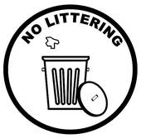  20. 不要随地扔垃圾！  bú yào suí dì rēnɡ lā jī

