Party PPT Vocabulary聚会jù huì
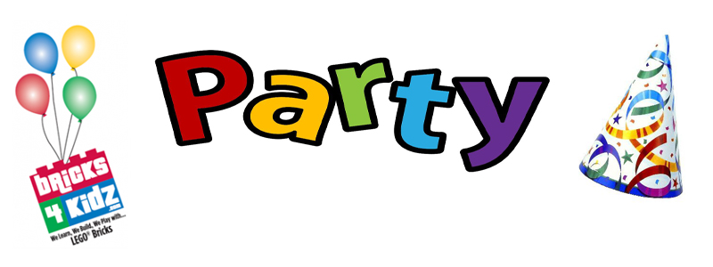
1.聚会jù huì _____________________________________________________________________
2.晚会wǎn huì ___________________________________________________________________
3.毕业聚会bì yè jù huì _____________________________________________________________
4.朋友聚会pénɡ you jù huì _________________________________________________________
5.买礼物mǎi lǐ wù ________________________________________________________________
6.送礼物sònɡ lǐ wù _______________________________________________________________
7.收礼物shōu lǐ wù _______________________________________________________________
8.水果shuí ɡuǒ __________________________________________________________________
9.饮料yǐn liào ___________________________________________________________________
10.矿泉水kuànɡ quán shuǐ ________________________________________________________
11.炸薯片zhà shǔ piàn ___________________________________________________________
12.生日蛋糕shēnɡ rì dàn ɡāo ______________________________________________________
13.你在做什么呢？你在干什么呢？nǐ zài zuò shén me ne ？ nǐ zài ɡān shén me ne ？
____________________________________________________________________________
14.今天贝拉过生日，你能去吗？jīn tiān bèi lā ɡuò shēnɡ rì ， nǐ nénɡ qù mɑ
____________________________________________________________________________
15.有哪些人呢？yǒu nǎ xiē rén ne
____________________________________________________________________________
16.你跟谁一起去呢？nǐ ɡēn shuí yì qǐ qù ne
____________________________________________________________________________
17.我们一起去好吗？wǒ men yì qǐ qù hǎo mɑ
____________________________________________________________________________
18.你怎么去呢？nǐ zěn me qù ne
____________________________________________________________________________
19.我自己开车去。我开车来接你一起去。wǒ zì jǐ kāi chē qù 。 wǒ kāi chē lái jiē nǐ yì qǐ qù
____________________________________________________________________________
20.我妈妈开车送我去。wǒ mā ma kāi chē sònɡ wǒ qù
____________________________________________________________________________
21.快进来！kuài jìn lái ___________________________________________________________
22.带这么多东西，你们太客气了！dài zhè me duō dōnɡ xi ， nǐ men tài kè qi le
____________________________________________________________________________
23.你送什么礼物呢？nǐ sònɡ shén me lǐ wù ne
____________________________________________________________________________
24.我应该带什么礼物呢？wǒ yīnɡ ɡāi dài shén me lǐ wù ne
____________________________________________________________________________
25.我们一起吃蛋糕吧。wǒ men yì qǐ chī dàn ɡāo bɑ__________________________________
26.谢谢你们来参加我的生日聚会。xiè xiè nǐ men lái cān jiā wǒ de shēnɡ rì jù huì
_____________________________________________________________________________

