My Daily Schedule我的一天wǒ de yì tiān:
- 起床qǐ chuáng _________________________________________
- 穿衣服chuān yī fu_______________________________________
- 刷牙shuā yá____________________________________________
- 洗脸xǐ liǎn __________________________________________
- 洗头发xǐ tóu fa_______________________________________
- 吹头发chuī tóu fa_____________________________________
- 刮胡子guā hú zǐ/刮胡须guā hú xū_______________________
- 吃早饭chī zǎo fàn/吃早餐chī zǎo cān_______________________
- 上学shàng xué__________________________________________
10．上课shàng kè __________________________________________
11． 吃中饭chī zhōng fàn /吃中餐chī zhōng cān /吃午餐chī wǔ cān
______________________________________________________
12. 下课xià kè ____________________________________________
13. 放学fàng xué _________________________________________
14．回家huí jiā ____________________________________________
15．吃晚饭chī wǎn fàn/吃晚餐chī wǎn cān _____________________
16．做作业zuò zuō yè/做家庭作业zuò jiā tíng zuò yè
______________________________________________________
17．看电视kàn diàn shì ______________________________________
18．玩电脑游戏wán diàn nǎo yóu xì/玩计算机游戏wán jì suàn jī yóu xì
______________________________________________________
19．洗澡xí zǎo _____________________________________________
20．睡觉shuì jiào ___________________________________________
21． 点diǎn _______________________________________________
22．半bàn _________________________________________________
23．刻kè __________________________________________________
24．分fēn __________________________________________________
25．秒miǎo ________________________________________________
26．经常jīng cháng/常常cháng cháng ___________________________
27．一般yì bān/通tōng cháng. ________________________________
28．有时yǒu shí _________________________________________
29．很少hěn shǎo/不常bù cháng ________________________________
30．从来不cóng lái bú________________________________________

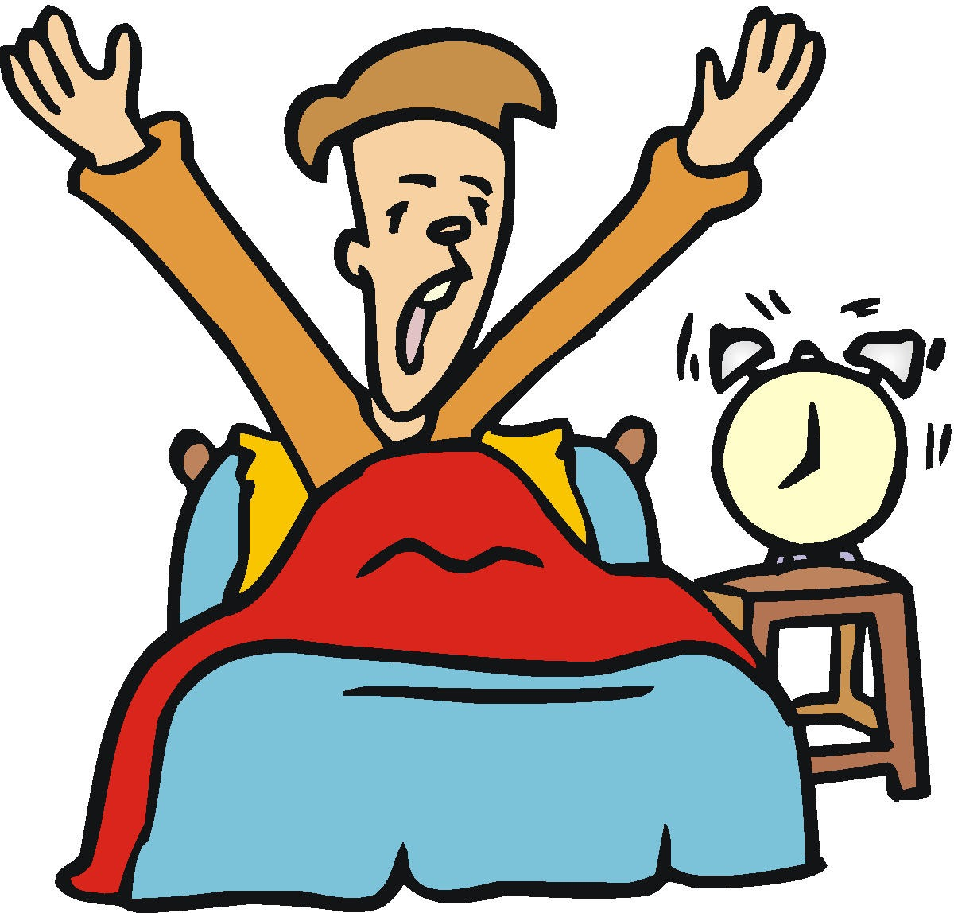  1.起床qǐ chuáng | 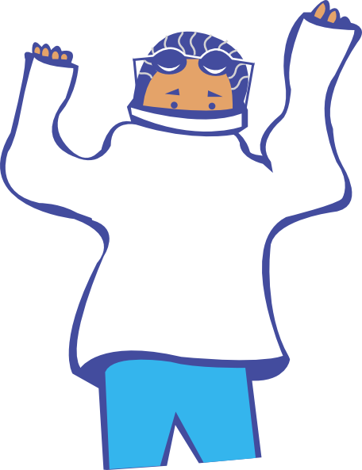  2. 穿衣服chuān yī fu
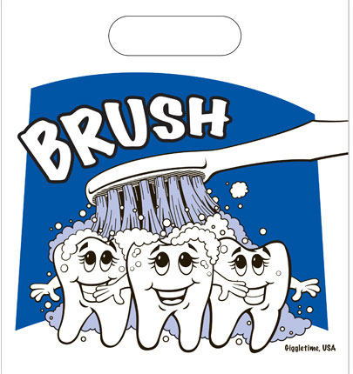  3. 刷牙shuā yá | 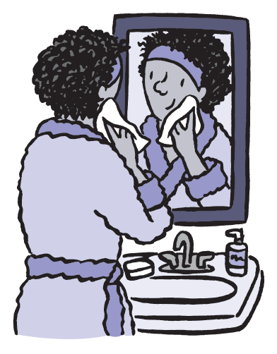  4. 洗脸xǐ liǎn
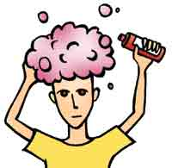  5. 洗头发xǐ tóu fa |   6. 吹头发chuī tóu fa
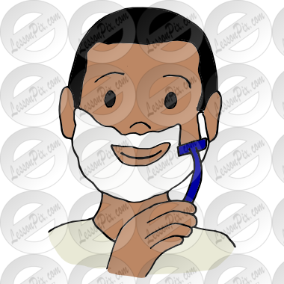  7. 刮胡子guā hú zǐ/刮胡须guā hú xū | 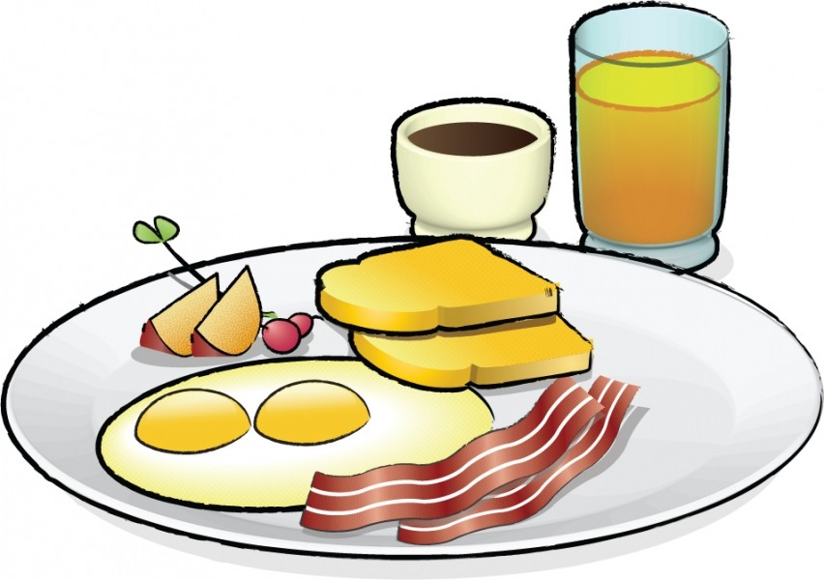    8. 吃早饭chī zǎo fàn/吃早餐chī zǎo cān
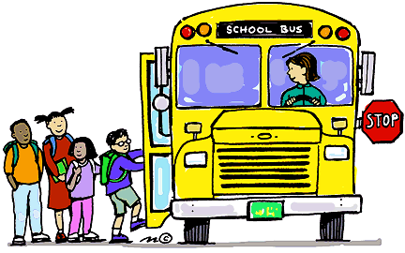  9. 上学shàng xué |   10. 上课shàng kè
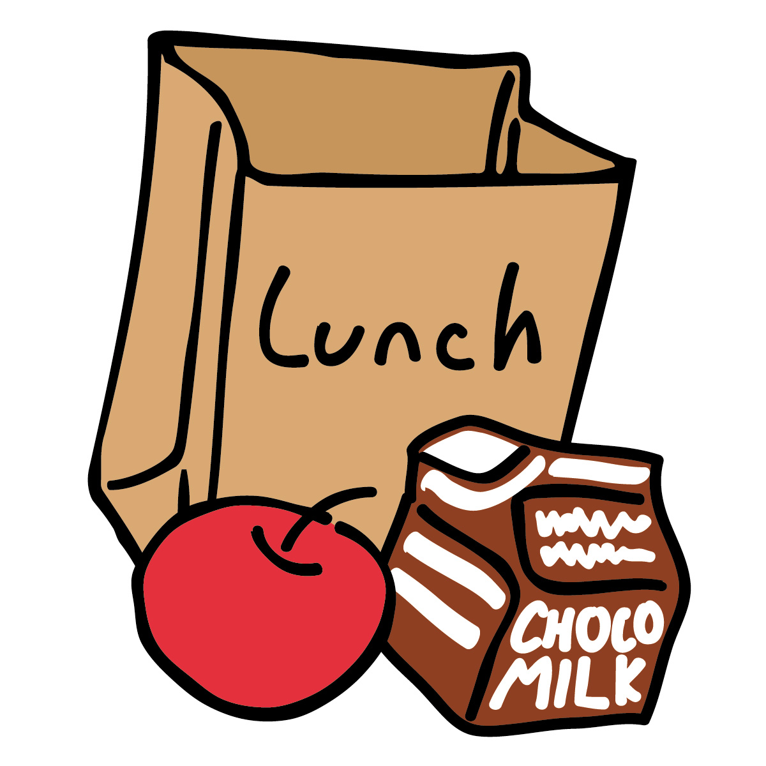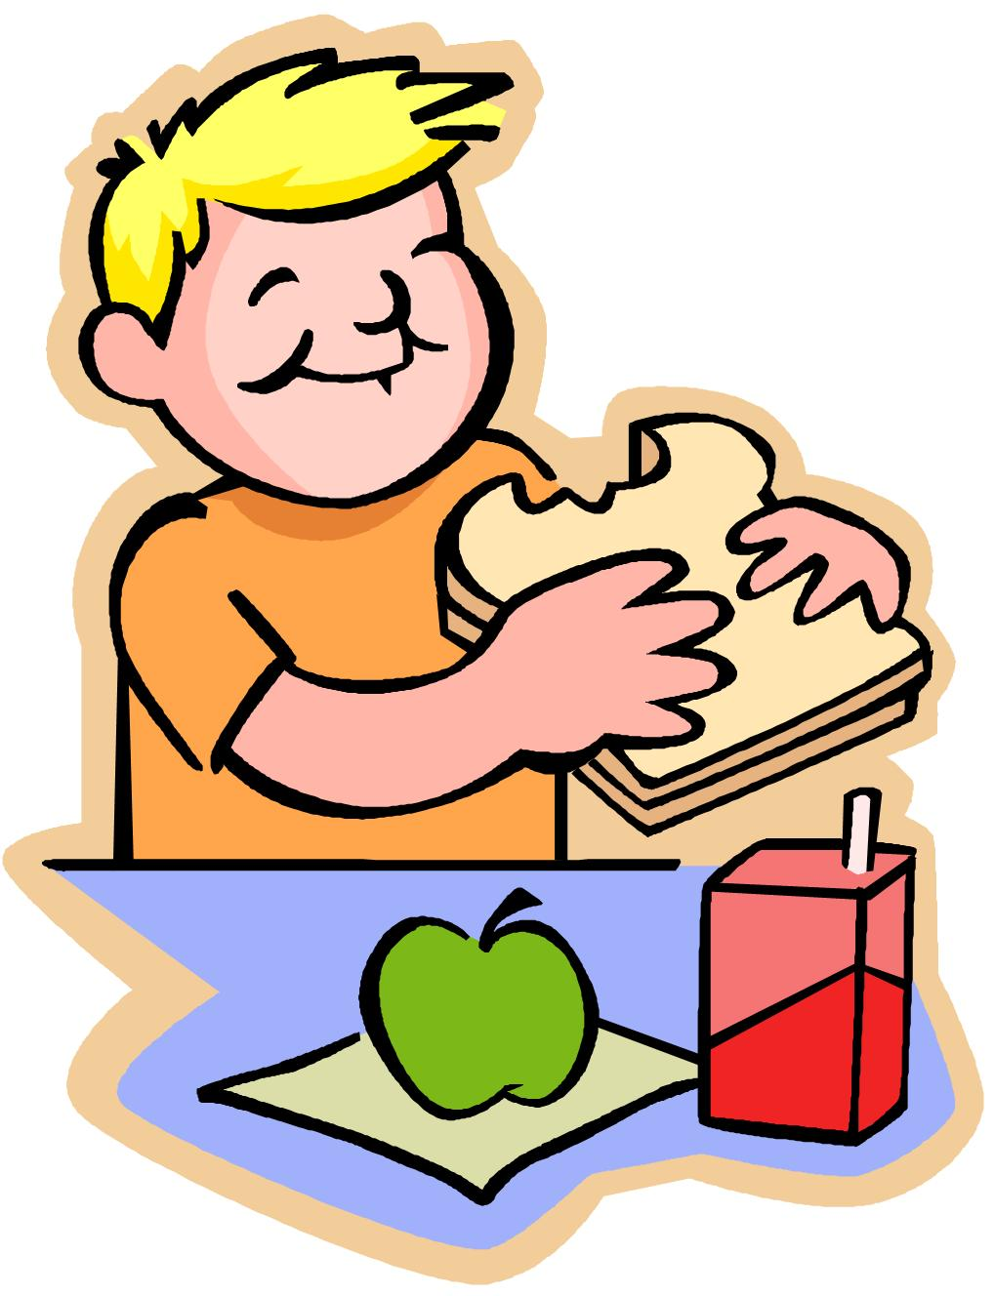  11. 吃中饭chī zhōng fàn /吃中餐chī zhōng cān  /吃午餐chī wǔ cān | 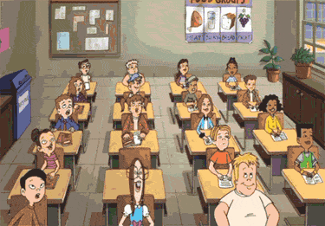    12. 下课xià kè
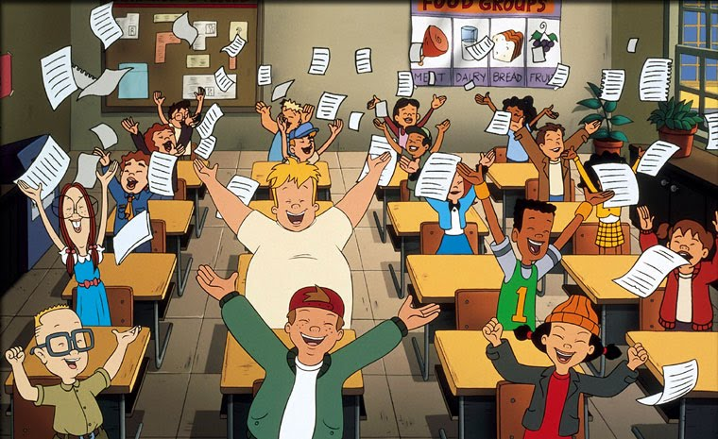  13. 放学fàng xué |   14. 回家huí jiā
  15. 吃晚饭chī wǎn fàn  /吃晚餐chī wǎn cān |     16. 做作业zuò zuō yè  /做家庭作业zuò jiā tíng zuò yè
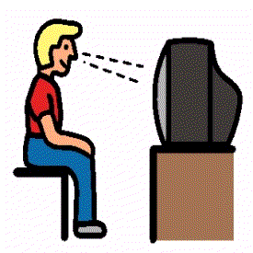  17. 看电视kàn diàn shì | 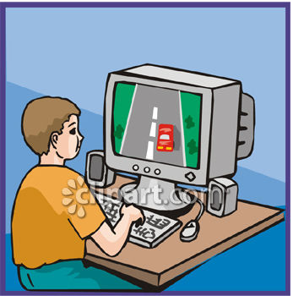  18. 玩电脑游戏wán diàn nǎo yóu xì  /玩计算机游戏wán jì suàn jī yóu xì
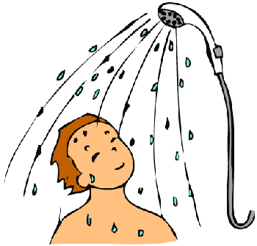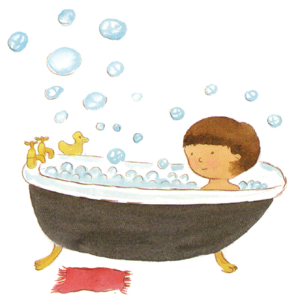  19. 洗澡xí zǎo |   20. 睡觉shuì jiào
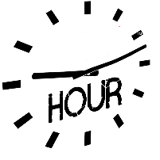  21． 点diǎn | 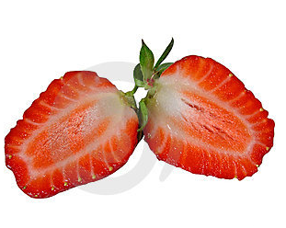  22. 半bàn
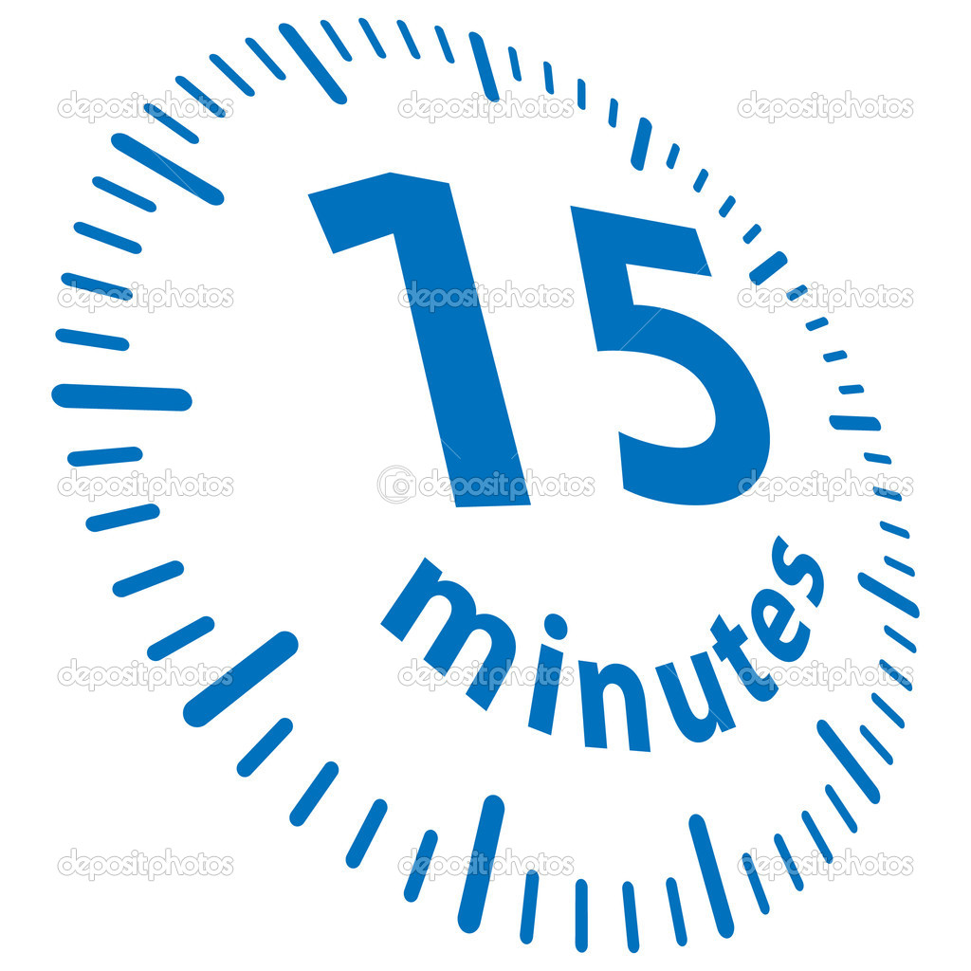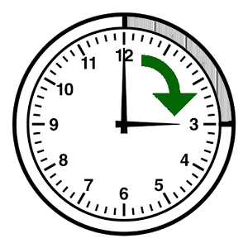  23. 刻kè |   24．分fēn
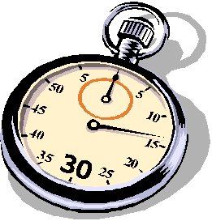    25. 秒miǎo | 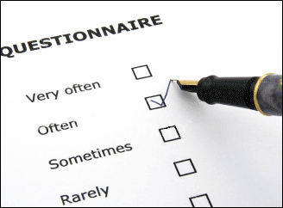  26. 经常jīng cháng/常常cháng cháng
  27. 一般yì bān/通常tōng cháng | 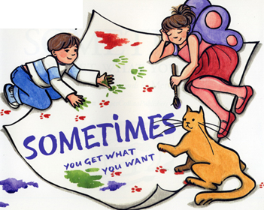  28. 有时yǒu shí
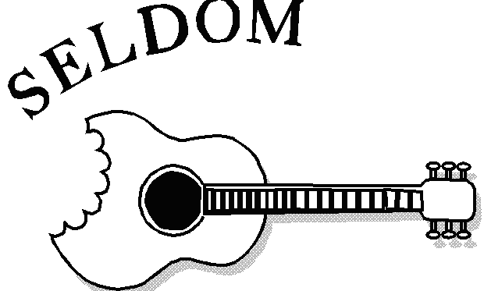  29. 很少hěn shǎo/不常bù cháng |   30. 从来不cóng lái bú

