Rules and Procedures: 2014 Michigan China Quiz Bowl
Check-In
• All coaches must check in at the registration area located in front of the main entrance of Chatterton Middle School located at 24333 Ryan Rd, Warren, MI 48091, between 8:30 and 9:00am. After registering, students and parents should report directly to the Cafeteria for the opening welcome.
• Coaches who have parents and other adults assisting them must ask for nametags for their assistants at the registration area.

Teams and Divisions
• Teams must have a minimum of two qualified participants. A maximum of four students may compete
on a team. A fifth and sixth student may attend as an alternate.
• Alternates may not "jump into" an ongoing match; they may only be "rotated in" between matches.
Alternates may NOT be shared by teams from the same school. If an alternate substitutes with one team, he or she may not substitute with another team.
• Eligible team members include only students in grades 6-12 who are non-native speakers and non-heritage learners* of Chinese, who have not lived or stayed in China for a combined total of more than 30 days, and who are not part of a Chinese program in which classroom instruction exceeds 10 hours per week, including weekend classes.
• Each team can participate in only one of the following divisions at either the middle school or high school level:
Division I - designated for students who have not yet completed a full year of Chinese study.
Division II - designated for students who have not yet completed two years of Chinese study.
Division III – designated for students who have not yet completed three full years of Chinese study.
Division IV – designated for students who have not yet completed four full years of Chinese study.
High school students who are registered in first, second, third, or fourth year Chinese need not count previous middle or elementary school study in determining their appropriate division.
(* "Heritage learners" are those who reside in homes where Chinese is used to communicate, even occasionally, by one or more household members. A non-native/non-heritage learner is one who has never resided in a home where Chinese (Mandarin, Cantonese or any Sino-Tibetan language or dialect) is spoken to anyone on any occasion or where he or she may rely on one or more native, heritage or other Chinese-speaking members of the household or immediate family to speak or to study Chinese. Please consult with the MCQB Advisory Committee if you have questions about eligibility.)

Preliminary Competition Rounds
• Spectators (including team alternates who are not presently competing) are NOT permitted in the rooms during the competition nor are they allowed to view competitions through windows.
• Students, coaches, parents, and guests must wait in designated areas when not competing and may under no circumstance wait directly in front of competition rooms in the hallway.
• Cell phones must be turned off during the competition. The use or sound of a cell phone during the competition may result in the disqualification of that team.
• There are 25 questions per round. Each round will take about 10 minutes, but extra time is allotted in case the matches take longer. Because division winners are determined by the average of all total scores, the competition will not end until all 25 questions are asked.
• The competition will begin when the score sheet arrives in the competition room, which will occur a few minutes after the designated start times. Officials should not wait for all team members to arrive as being on time is the responsibility of each participant. Once the door is closed, the competition may commence. No one else will be allowed to enter at this point.
• Team members who arrive late to a match will not be admitted. Teams may play with less than four members but no fewer than two.
• If an entire team misses a match for any reason, the team that was present will win the match and earn points based on their average points from the other rounds. The team that missed the match will forfeit and receive "0" points.
• Students must wear nametags at all times.
• There are a minimum of three rounds of preliminary competition (four rounds for some teams, depending on scheduling). The two teams with the highest average number of points in each division will proceed to the Final Round. Teams finishing third and fourth in their division will automatically receive their respective prizes at the end of the championship rounds. In case there is a tie for the top two teams, the second and third place teams, the third and fourth place teams, or the fourth and fifth place teams, a tie-breaker match will be held at the end of the preliminary competition. Please pay attention to all announcements!
• The judges' decisions are final and should not be challenged during competitions. If there is a concern or question about the competition, the team member or other team-affiliated person must talk with his/her team coach.
• If the team coach is unable to respond to the concern or question, the team coach should talk to the MCQB Grievance Team. To lodge a formal complaint, the coach must complete and sign a grievance form and submit it to the Grievance Team in the Statistician’s Room or Media Center. All concerned parties (as determined by the Grievance Team) will be brought forth for questioning. The Grievance Team may then make a ruling that could result in nullifying a match or disqualifying a team or school from the current competition and possibly from future competitions. Team members, coaches, and team-affiliated people MUST NOT directly challenge the decision of a judge. If this occurs, that school may be disqualified immediately and/or from next year's MCQB competition.

Final Competition Round
• The final competition round is conducted in a quiz bowl format like that of the preliminary competition, but on stage in front of an audience.
• Any attempt to record (by writing, audio/videotape, or otherwise) ANY competition questions from any round is STRICTLY PROHIBITED and may result in the team and/or school with which the offender is associated to be disqualified immediately and/or from the following year's MCQB competition. Please put away all cameras, video equipment, computers, and writing utensils. Pictures will be taken by one designated photographer and posted online approximately two weeks after the competition.
• Spectators may not speak, make sounds, take notes, videotape, record, or create any disturbances during the final round. Judges (or MCQB chairs) have the authority to ask spectators to leave.
• The final match for each division is ten minutes. In the event of a tie, the judge asks a tiebreaker question until one team wins.

Team Consultation Questions
• Two questions per team per round.
• Team captains do "剪刀, 石头, 布," (jiǎn dāo, shí tóu, bù) “scissors, rock, cloth,” and the winning team goes first.
• The judge asks a question to one team. Only that team can answer the question.
• Team members may consult amongst themselves. They may speak out loud since the other team is ineligible to answer a missed question.
• The team captain must answer the question within 30 seconds. (The timekeeper will announce the time.)
• The other team must sit quietly while the opposing team is working on a question.

Toss-Up Language & Geography Questions
• Eight (8) language-oriented questions will be asked, followed by five (5) geography questions per round.
• Consultation amongst team members is not permitted.
• The first person to buzz in must answer the question within 5 seconds.
• If the first person's answer is incorrect, or they take longer than 5 seconds to answer, then the other team is asked to press the buzzer to answer.
• If the first person buzzes in the middle of the judge's sentence and does not give the correct answer, the judge will read the full question again for the OTHER TEAM.
• The judge then asks the other team if they need to hear the question again.
•If no one buzzes in, then the judge moves to the next question.

Visual Questions
• 8 questions total per round.
• Students in Divisions I-II look at a screen to read Chinese characters. They also give their meanings in English.
- Characters on the left are given in simplified Chinese; characters on the right are given in traditional Chinese.
• The judge pays close attention to correct pronunciation.
• The procedure is the same as the toss-up questions.
• Consultation among teammates is not allowed.
• Below are examples of Division I-II reading questions:
图书馆 | 圖書館
学校 | 學校
• Each word must be pronounced and translated correctly in order to get a point.
• The questions must be answered within five (5) seconds as in the case of the toss-up questions. If the student takes too long to read a word, then the judge says, "I am sorry, time is up."
• If the pronunciation is not acceptable, then the judge says, “I am sorry, that is incorrect.”
• If the student's answer is incorrect, then someone from the OTHER TEAM may buzz in and answer within 10 seconds.
• If no one buzzes in, then the judge moves on to the next question.

OTHER K-12 PROGRAMS SPONSORED BY THE CONFUCIUS INSTITUTE AT WAYNE STATE UNIVERSITY

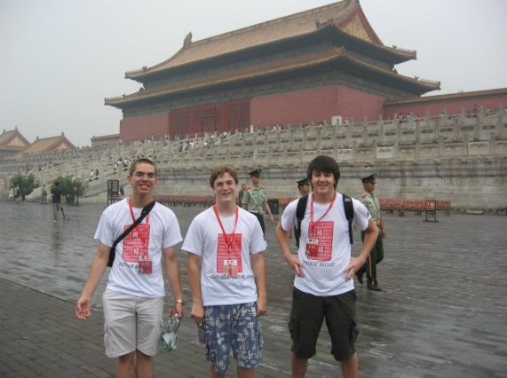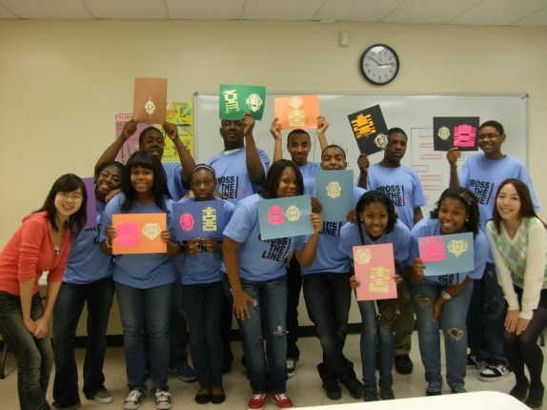
High School China Bridge Program K-12 Outreach Program
Selected students enjoy two weeks of sightseeing Volunteers from Wayne State University
and studying Chinese language and culture in visit Detroit area K-12 schools, providing
China. Students pay for only airfare and visa supplemental instruction and activities.

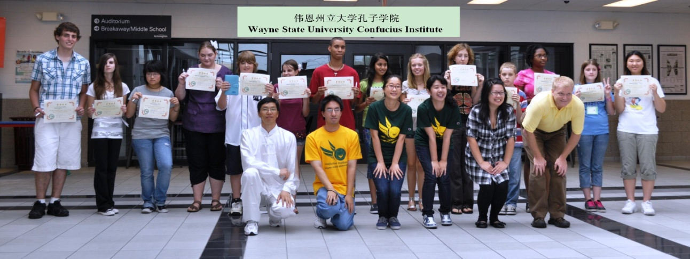
China Corps Summer Camps
Two to three weeks of Chinese language and cultural study for middle and high school students are offered at locations in Macomb, Oakland, and Wayne counties. Should your school be interested in hosting a Chinese summer camp, please contact the WSU-CI.

